BALTZER MEYER HISTORICAL SOCIETY
2024 Meeting Schedule

June 8th 2024 12-2 PM
Ronel Baccus will be speaking about the Commemoration of the Emancipation Proclamation of 1862.

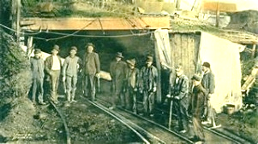
June 22nd 2024 1 PM-3 PM
John Hepple to speak on the Darr Mine disaster at Van Meter, Rostraver Township, near Smithton, that killed 239 men and boys on December 19, 1907. It ranks as the worst coal mining disaster in Pennsylvanian history. Many victims were of immigrants from central Europe,

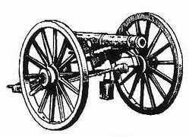
July 13th 2024 1 PM-3 PM
Ken Williams recognizes the importance of the Battle of Gettysburg. Williams' family has special ties to the Civil War. When people think of the Battle of Gettysburg, their mind typically goes to the actions that played out on the battlefields. But what is commonly overlooked is the experience of the people who lived in Gettysburg who were affected by the battle long after the cannons fell silent.


July 27th 1 PM-3 PM
Ron Maxson will speak about Marine Corp history. He is an avid collector and
will bring some of his memorabilia with him.

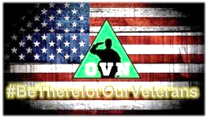
Aug 3rd 2024 8:30 AM-2:30 PM
5th Annual Operation Vet Now (OVN) Fallen Heroes Ride & Veteran/Military Appreciation event. Z&M Harley-Davidson. Come join the event and see our informational booth.

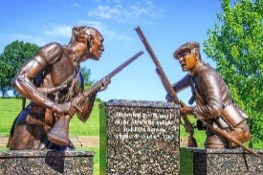
August 3 and 4, 2024
261th Anniversary Reenactment at Bushy Run Battlefield. Witness a clash of cultures as historical reenactors bring the Battle of Bushy Run to life! Each year, the BRBHS commemorates the Battle of Bushy Run with a large-scale, reenactment. We will have an informational booth at this event.

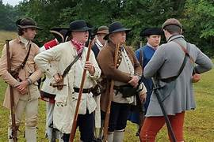
August 18th 2024 12-4PM
Ancestry Day. Free research in our Library all this month. Reenactors, Bill and Luren Koker will speak about early military life. Their toddler, Nathanial, will join us in his costume. Demonstration of vintage skill of twining. Tour the Historical Society and Harrold School #8. Participate in our Basket Raffle.

BALTZER MEYER HISTORICAL SOCIETY
2024 Meeting Schedule
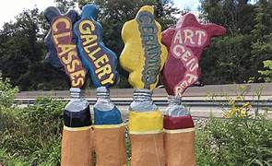
September Sunday 8th 2024 2-4 PM
Pat Majcher of the Greensburg Art Center on Todd School Road will speak. The group started in 1929. She will show us some work of some of the many local artists.


October 5th 2024 2 PM-4 PM Author Series
Scott Pavell will talk about heritage cookies. These cookies and their traditions were brought to America when families immigrated here. They offer something different: tried, tested and perfected versions of those old classics from around the globe. Scott will have copies of Heritage Cookies available.

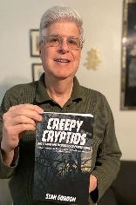
October 19th 2024 2-4 PM Author Series
Stan Gordon will present a program on the stranger aspects of Bigfoot as well as an update on some of the more interesting recent cases. You will hear about some of the strangest cases ever documented about Bigfoot. Stan will also give an update on more recent UFO and Bigfoot cases that have been reported and he will be doing a book and DVD signing after the presentation.

November 9th, Saturday 2024 3-5PM
Veterans’ Dinner with Ronel Baccus. If you are a veteran or know some veterans, come share a social dinner with us.

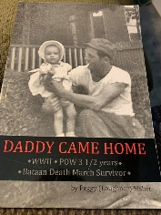
November 17th 2024 2-4 PM Author Series
Peggy Fisher will share her daddy’s WWII story. He endured some of the worst atrocities our soldiers experienced in the Philippines and Japan. We will learn not only of his struggles, but those of his family while he was in the service and after he came home. She has written his story in Daddy Came Home and will have copies of her book available.


December 15th 2024 2-4 PM
Christmas Potluck Party. Rachel Kayhart will read a Victorian Christmas Story. You may not know but ghost stories became a Christmas tradition in Victorian England.

